For the Co-relation demonstration, I have considered the stock prices and their movement for certain days. I have used the ticker symbols in the chart. Below are their corresponding Names.

BLNK – Blink Charging

PLUG – Plug Power

TSLA - Tesla

BABA - Alibaba

MSFT - Microsoft

SBUX - Starbucks

DIS - Disney

MRNA - Moderna

**Positive Co-relation:**

In the below example, we can clearly see that there is positive co-relation between Blink Charging and Plug power stocks. AS Blink Charging stock goes up, plug power stock also went up same can be implied for stocks Tesla and plug power.

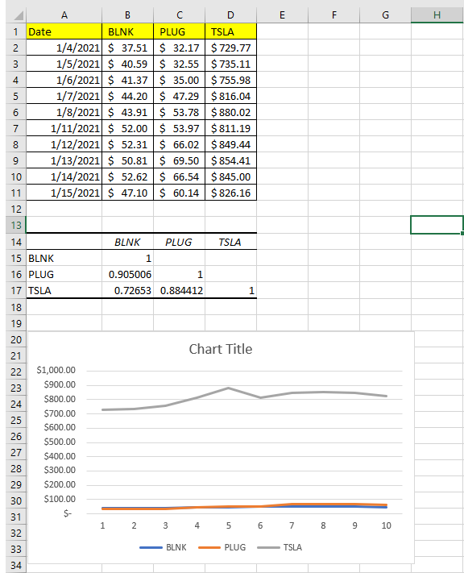

**No Co-relation:**

In the below example, there is no co-relation between Microsoft and Alibaba. Price movement of Microsoft and Alibaba are independent of each other. There are cases where Microsoft went up, but Alibaba went down and vice versa. Same can be inferred for Microsoft and Starbucks.

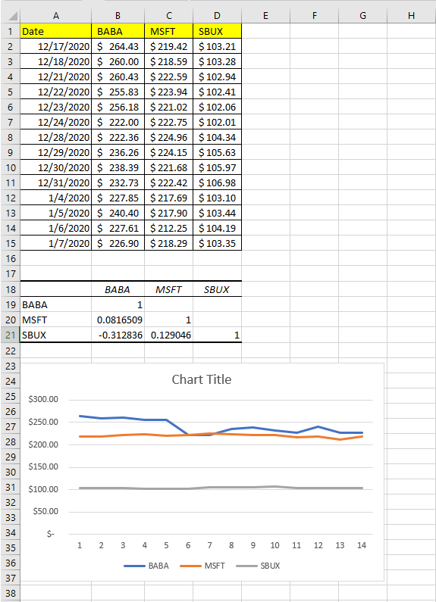

**Negative Co-relation:** In the below example, we can see that Disney and Moderna are negatively co-related.in Most of the days from the below example, as Disney Stock went up, Moderna went down and vice versa.

